SQL Assignment 4

/*1.Create a stored procedure in the Northwind database that will calculate the average

value of Freight for a specified customer.Then, a business rule will be added that will

be triggered before every Update and Insert command in the Orders controller,and

will use the stored procedure to verify that the Freight does not exceed the average

freight. If it does, a message will be displayed and the command will be cancelled*/

/*2. write a SQL query to Create Stored procedure in the Northwind database to retrieve

Employee Sales by Country

*/

Create Procedure empsalesbycountry

@country nvarchar(20)

AS

begin

select Employees.EmployeeID ,Employees.FirstName,Orders.ShipCountry,sum("Order Subtotals".Subtotal) AS Total_sales from Employees

Inner Join (Orders INNER JOIN "Order Subtotals" ON Orders.OrderID = "Order Subtotals".OrderID)

ON Employees.EmployeeID=Orders.EmployeeID

Where Orders.ShipCountry=@country

group by Employees.EmployeeID ,Employees.FirstName,Orders.ShipCountry

Order by EmployeeID ASC

end

empsalesbycountry 'USA'

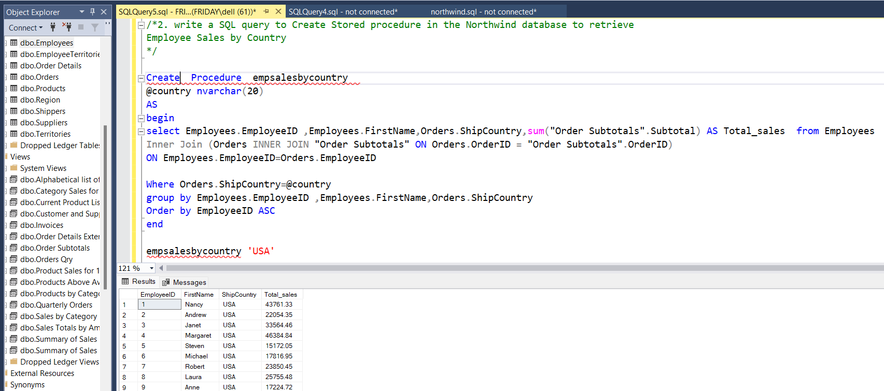

/*3. write a SQL query to Create Stored procedure in the Northwind database to retrieve

Sales by Year*/

Create Procedure salesbyyear

@year int

AS

Begin

Select year(Orders.OrderDate) as year ,Sum([Order Subtotals].Subtotal) as total_sales from Orders

Inner join [Order Subtotals]

On Orders.OrderID=[Order Subtotals].OrderID

Where Year(Orders.OrderDate)=@year

group by year(OrderDate)

End

salesbyyear 1996

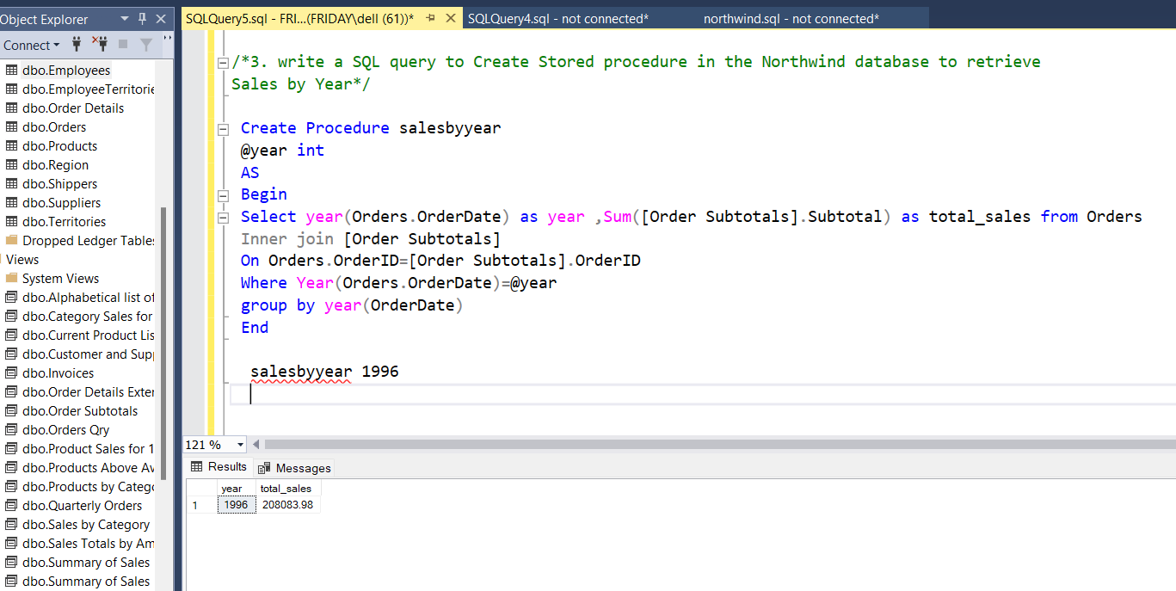

/*4. write a SQL query to Create Stored procedure in the Northwind database to retrieve

Sales By Category*/

Create Procedure salesbyCategory

@category nvarchar(30)

AS

BEGIN

Select categories.CategoryID,CategoryName,Count(OrderID) as NoOfOrders from Categories

Inner Join (Products Inner Join [Order Details] on Products.ProductID=[Order Details].ProductID)

On Categories.CategoryID=Products.CategoryID

Where CategoryName=@category

Group By Categories.CategoryID,Categories.CategoryName

End

Execute salesbyCategory 'Beverages'

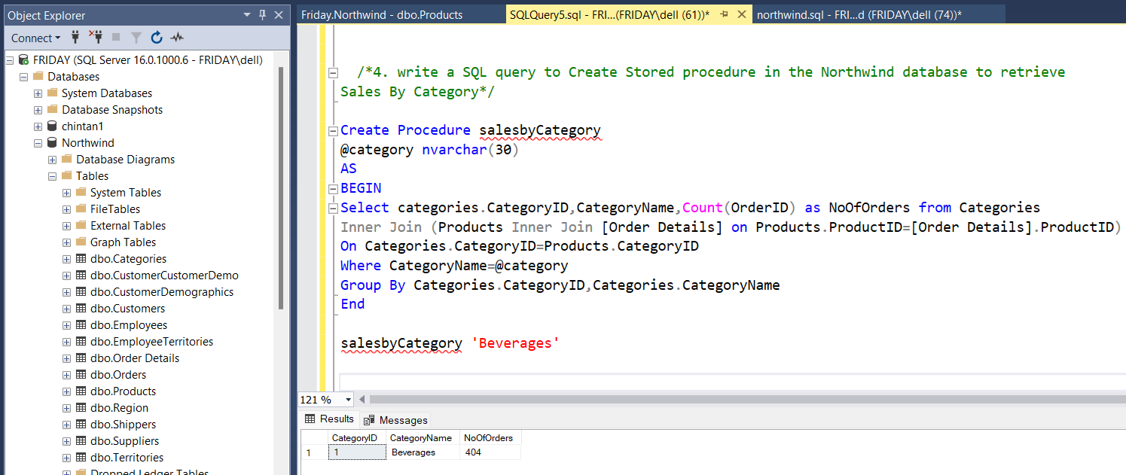

/*5. write a SQL query to Create Stored procedure in the Northwind database to retrieve

Ten Most Expensive Products*/

Create Procedure Gettop10Products

As

Begin

Select top 10 Products.ProductID,Products.ProductName,Products.UnitPrice from Products

order by Products.UnitPrice DESC

End

Execute Gettop10Products

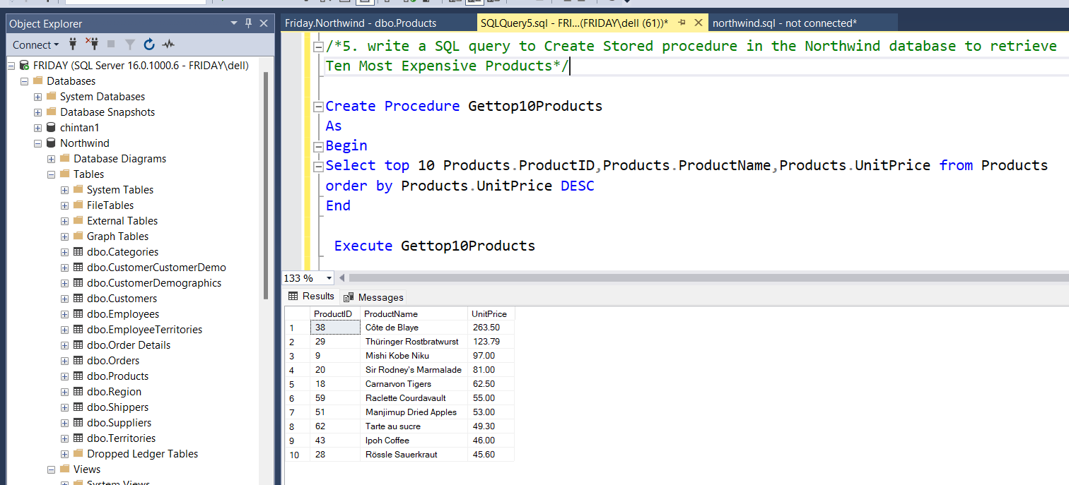

/*6. write a SQL query to Create Stored procedure in the Northwind database to insert

Customer Order Details */

Create Procedure InsetOrderDetails

@OrderID int, @ProductID int, @UnitPrice float ,@Quantity int,@Discount float

AS

Begin

Insert into [Order Details] Values

(@OrderID , @ProductID , @UnitPrice ,@Quantity ,@Discount)

End

Execute InsetOrderDetails @OrderID =10259, @ProductID=2 , @UnitPrice =15.2,@Quantity=50 ,@Discount=0.2

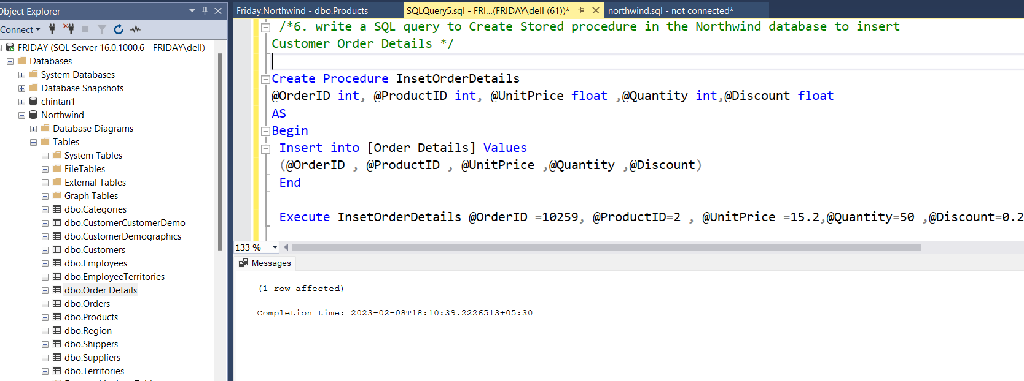

/*7. write a SQL query to Create Stored procedure in the Northwind database to update

Customer Order Details*/

Create Procedure UpdateOrderDetails

@ProductID int,@OrderID int, @UnitPrice float ,@Quantity int,@Discount float

AS

Begin

UPDATE [Order Details]

SET ProductID=@ProductID , UnitPrice=@UnitPrice ,Quantity=@Quantity ,Discount=@Discount

WHERE OrderID=@OrderID

End;

Execute UpdateOrderDetails @OrderID =17999, @ProductID=2 , @UnitPrice =15.2,@Quantity=50 ,@Discount=0.3

